The Calgary Model Sailing Association is pleased to announce the 2015 edition of
The September Blender, the first Prairie Regional ranking event! The Blender will be held September 18th to 20th in Calgary, Alberta at the Glenmore Reservoir. Great competition, an excellent venue and renowned Alberta hospitality make this a must-do event. The Blender offers so much more than a fantastic r/c sailing event. Calgary is located in the foothills of the Canadian Rockies and is surrounded by nationally renowned parks, museums, cities and much more. We encourage you to extend your stay and see what our province has to offer. We're all looking forward to an excellent 2 days of racing, camaraderie and new friendships!

Calgary is located 1 hour east of the Canadian Rockies along Highway 1, the Trans-Canada Highway and the major east-west road through the nation. From Montana, Calgary can also be reached via Highway 2, crossing at the Carway Border Crossing or the Coutts Border Crossing.

The venue: Glenmore Sailing Club's club house at 8601 24th Street SW in South Glenmore Park. The club's website (www.glenmoresailingclub.com) and map.

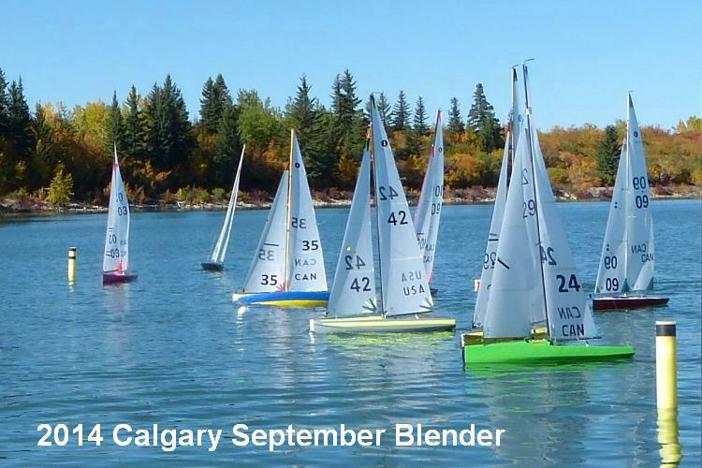

Alberta: We encourage you to arrive early or stay late after the September Blender. There's a lot to see in Alberta. Banff National Park, Canada's oldest national park, is located 90 minutes west of the city and is world-renowned for its' easy access to the grandeur of the Canadian Rockies. Further past the townsite of Banff is Lake Louise, and north of Lake Louise is the Icefields Parkway and the townsite of Jasper. Northeast of Calgary, and scenically a world away from Banff, is Drumheller. Also a 90 minute drive from Calgary, Drumheller is located in the Alberta Badlands and is home to the Royal Tyrell Museum, considered one of the finest dinosaur museums in the world. There is so much more to Alberta than what this paragraph can offer, so please visit these excellent websites; Travel Alberta (www.travelalberta.com) or Visit Calgary http://www.visitcalgary.com/ both excellent resources for ideas and destinations throughout Alberta and Calgary.

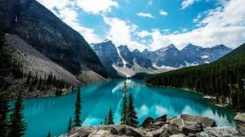
Banff National Park

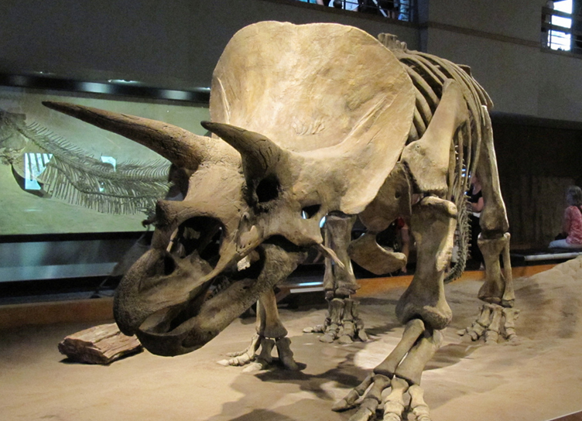
Drumheller, Royal Tyrrell Museum

Getting here: The Calgary International Airport (YYC) serves many airlines and is the headquarters of WestJet and a major hub for Air Canada. It is also a destination for the majority of US airlines including American, Alaska, Delta and United. All of the major car rental agencies have desks at YYC and there are taxi, limo and transit options to get you to your accommodations.

Staying in Calgary: A limited number of billets are available through the members of the CMSA. There are many hotels / motels a very short drive to the Glenmore Reservoir. RV camping, including up to 45’ coaches, is available at the western edge of the city and is a short 15 minute drive to our venue.

CMSA will do all they can to ensure your regatta is an enjoyable one. If you're looking for some, “local's only, “advice or if you have any questions or concerns about the event do not hesitate to contact one of us below. We're here to host and to help. See you in September!

CMSA

Mark Verrey snowbirds2043@gmail.com
Andrew Baak sailorbaak@yahoo.com
Chris Hunt res3ch71@shaw.ca

